Task 3 – SQL query practice
SELECT * FROM Patients;
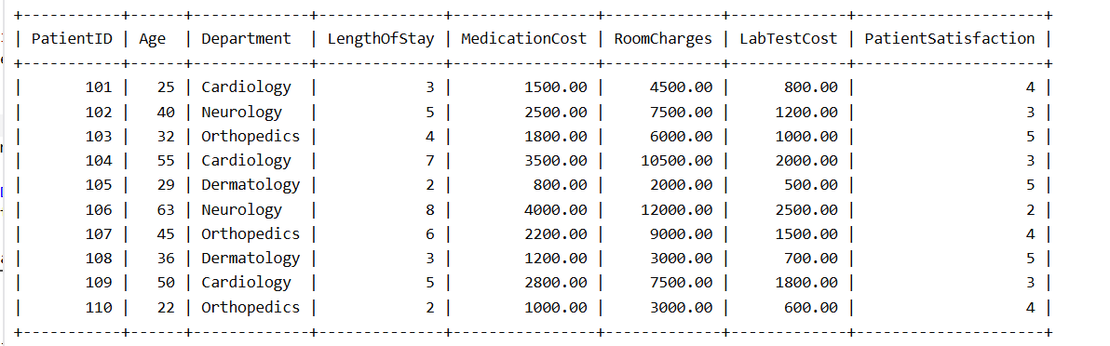
SELECT *
FROM Patients
WHERE Department = 'Cardiology';

SELECT PatientID, Age, Department, LengthOfStay
FROM Patients
WHERE Age > 40
AND LengthOfStay > 5;
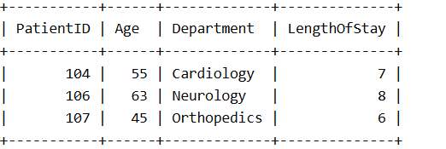
SELECT PatientID, Department, MedicationCost
FROM Patients
ORDER BY MedicationCost DESC;
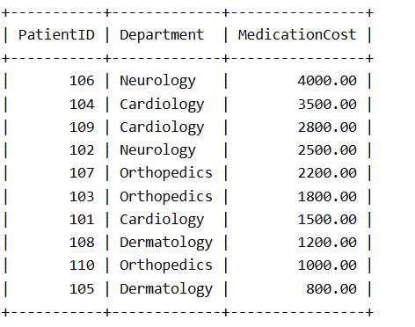
SELECT SUM(MedicationCost) AS TotalMedicationCost
FROM Patients;

SELECT AVG(PatientSatisfaction) AS AverageSatisfaction
FROM Patients;

SELECT
Department,
COUNT(*) AS TotalPatients
FROM Patients
GROUP BY Department;

SELECT
Department,
AVG(MedicationCost) AS AverageMedicationCost
FROM Patients
GROUP BY Department
HAVING AVG(MedicationCost) > 2000;


